**Multidimensional Structure**

**بعد التعديل**

**Definition:**

Multidimensional structures or hypercubes are commonly used in OLAP to store and organize data to optimize query response time.

**Explanation:**

Multidimensional structures have discrete values and are organized in different levels of hierarchies.

It is often a type of databases which is meant to take advantage usage of storing as well as using info. Usually integrated to be able to optimize on the internet logical processing (OLAP) also data storage warehouse programs.

**Example**:

**OLAP (Online Analytical Processing):**The technology is the use of many BI (Business Intelligence) operations. And it is a powerful technology for data discovery, reports, analytical calculations, and predictive analysis planning.

**Diagram:**

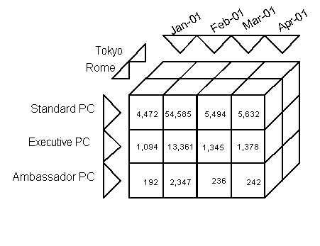

**Object-Oriented Structure**

**Definition:**

**object**-**oriented** programming (**OOP**) refers to a type of computer programming (software design) in which programmers define the data type of a data **structure.**

**Explanation:**

the data structure becomes an [object](https://www.webopedia.com/TERM/O/object.html) that includes both [data](https://www.webopedia.com/TERM/D/data.html) and functions.

In addition, programmers can create relationships between one object and another

**Example:**

For example, we have information about nature and printing on living things that the student can search for living things, Century of this type can be any individual student class at the university

**Diagram:**

